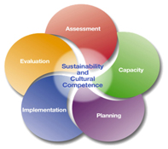
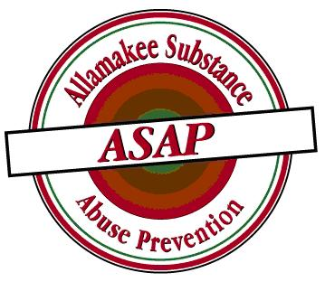
Allamakee Substance Abuse Prevention
110 Allamakee Street • Waukon, IA 52172
(563) 568-2204

ASAP SPF SIG

After considerable research to understand current drinking behaviors, attitudes, concerns and motivations, of an Iowa teenager regarding underage drinking; the Iowa Strategic Prevention Framework State Inventive Grant (SPF SIG) Project set out to launch a media campaign that was easy to grasp, strong in its message, and which included everyone and clicked for everyone--with stopping power.

The Iowa Strategic Prevention Framework State Incentive Grant Project in December, 2011 launched an award-winning media campaign that did just that. The “Bottle Cap”/”What Do You Throw Away When You Drink” campaign was that message. Allamakee County SPF SIG along with the other 22 SPF SIG counties in Iowa were given this campaign to use in each of their counties to help spotlight the issue of underage drinking. By itself, it was not intended to combat underage drinking, but meant to start discussions, and perhaps, if reached early enough, empower young people to take control of their lives to not drink alcohol.

Allamakee County SPF SIG has had great success with this campaign. It has been used by way of billboards, radio ads, television commercials, movie theater commercials, posters in schools, posters in businesses, and placed in the student section of the newspaper. Allamakee SPF SIG has also used this poster as a sticker placed on popcorn bags, given out at school athletic events and functions. The sticker was further placed in student planners, and this final year of SPF SIG placed on student textbook book covers. Allamakee SPF SIG also used the different versions of the “What Do You Throw Away When You Drink” posters as screen savers which have been used at municipal library computer labs and in school computer labs.

Allamakee County SPF SIG evaluated the effect of this campaign each year of the project and with the last year had 100% of students surveyed saying they had seen the campaign in some format or another.

